SQL Exercises

***https://www.w3schools.com/sql/trysql.asp?filename=trysql_desc***

1. Show all rows for Customers

SELECT * FROM Customers

1. Show only Contact name information for Customers

SELECT ContactName FROM Customers

1. Show all unique combinations between Cities and Countries for the customers

SELECT DISTINCT City, Country FROM Customers

1. Insert 3 new Customers

INSERT INTO Customers(CustomerName, ContactName, Address, City, PostalCode, Country)

VALUES('Ivan Angelov', 'Peter Know', 'Mladost', 'Sofia', '10000', 'Bulgaria')

INSERT INTO Customers (CustomerName, Address, City)

VALUES ('Poli Ivanova','Drujba','Sofia')

INSERT INTO Customers(CustomerName, ContactName, Address, City, PostalCode, Country)

VALUES('Ana Raycheva', 'Martin Kostov', 'Nadejda', 'Sofia', '10020', 'Bulgaria')

1. Move all orders made by Andrew Fuller to Nancy Davolio

UPDATE Orders

SET EmployeeID='1'

WHERE EmployeeID='2';

1. Group all products by category and show category name

SELECT p.productname, p.categoryid, c.categoryname

FROM Products p

inner join categories c

on p.categoryid = c.categoryid 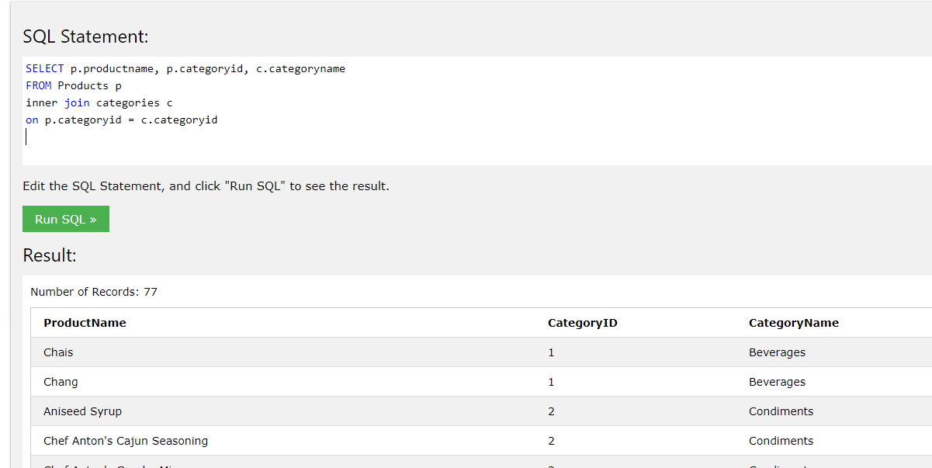

1. Sort all employees by Last Name and delete the last one. Do not remember to move all his/her orders to another colleague

UPDATE Orders

SET EmployeeID='1'

WHERE EmployeeID='10';select

delete from employees

where LastName='West'

and FirstName='Adam'

1. Show all customers without orders

SELECT customername, orderid FROM Customers c

left join orders o

on c.customerid = o.customerid

where orderid is null

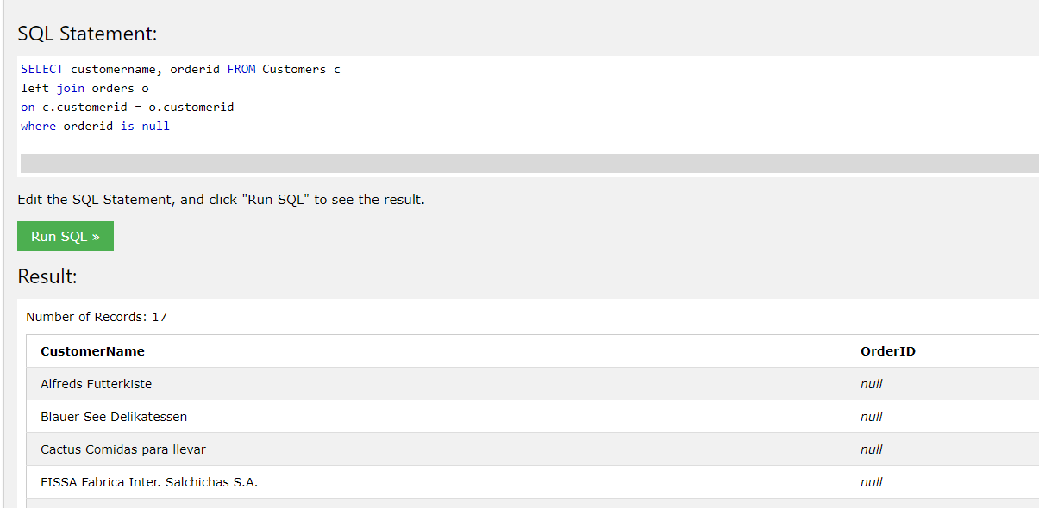

1. Show all products including 'ch' in its name with price between 10 and 20

SELECT * FROM Products

WHERE ProductName LIKE '%ch%'

and Price BETWEEN 10 AND 20;

1. Group all products from 9 by category and sort by count in descending order

SELECT * FROM Products

WHERE ProductName LIKE '%ch%'

and Price BETWEEN 10 AND 20

order by CategoryID desc